### **Project 1: LED Blink**

**Description：**

[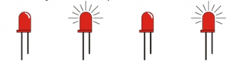](https://wiki.keyestudio.com/File:0085=26.png)

we start from simple projects. For this lesson we will perform “Arduion blinks LED”, which is the basic practice for starter. We provide a test code to control LED to perform blinking effect. In the code, you could set distinct flashing scene by changing the time of lighting on and off. Power on GND and VCC, the LED will light on when signal end S is high level, on the contrary, LED will turn off when signal end S is low level.

**Specifications：**

* Control interface: digital port
* Working voltage: DC 3.3-5V
* Pin pitch: 2.54mm
* LED display color: white
* Size: 30 * 20mm
* Weight: 3g

材料：

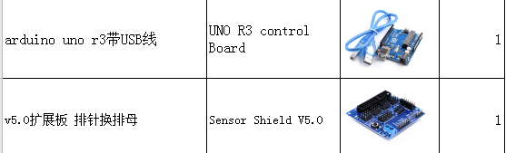

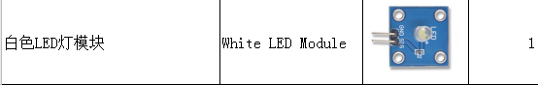

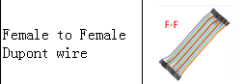

接线：

GND -- GND

SIG -- D13

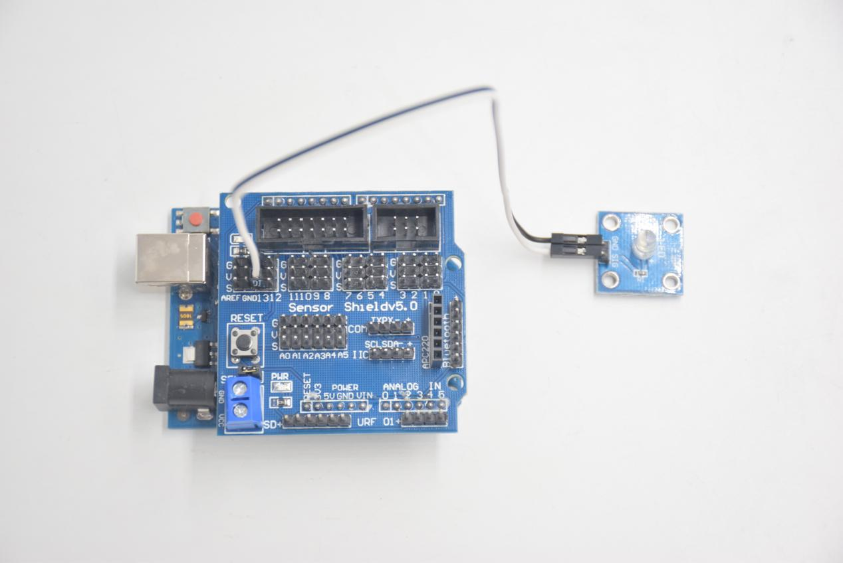

code：

void setup() {

// initialize digital pin 13 as an output.

pinMode(13, OUTPUT);

}

// the loop function runs over and over again forever

void loop() {

digitalWrite(13, HIGH); // turn the LED on (HIGH is the voltage level)

delay(1000); // wait for a second

digitalWrite(13, LOW); // turn the LED off by making the voltage LOW

delay(1000); // wait for a second

}

**Test Result：**

Upload test code successfully, white LED starts blinking, lights on for 1000ms, lights off for 1000ms, alternately.

**Code Explanation**

The code looks long and clutter, but most of which are comment. The grammar of Arduino is based on C.  
Comments generally have two forms of expression:  
  
/* .......*/ : suitable for long paragraph comments  
  
// : suitable for mono line comments

So the code contains the many vital information, such as the author, the issued agreement, etc.

Most people omit comments, starter should develop a good habit of looking through code. Firstly, check comments. They contain the provided information and do help you understand test code quickly. Secondly, form the habit of writing comments

// the setup function runs once when you press reset or power the board

void setup() {

// initialize digital pin 13 as an output.

pinMode(13, OUTPUT);

}

According to comments, we will find that author define the D13 pin mode as digital output in setup() function. Setup() is the basic function of Arduino. It will execute once in the running of program, usually as definition pin, define and ensure the variables.

// the loop function runs over and over again forever

void loop() {

digitalWrite(13, HIGH); // turn the LED on (HIGH is the voltage level)

delay(1000); // wait for a second

digitalWrite(13, LOW); // turn the LED off by making the voltage LOW

delay(1000); // wait for a second

}

Loop() is the necessary function of Arduino, it can run and loop all the time after “setup()” executes once  
In the loop()function, author uses  
digitalWrite(13, HIGH); // turn the LED on (HIGH is the voltage level)

digitalWrite(): set the output voltage of pin to high or low level. We make D13 output high level, then the LED lights on.  
delay(1000); // wait for a second  
Delay function is used for delaying time, 1000ms is 1s, unit is ms

digitalWrite(13, LOW); // turn the LED off by making the voltage LOW  
Similarly, we make D13 output low level, LED will turn off.  
delay(1000); // wait for a second

Delay for 1s, light on LED--keep on 1s--light off LED--stay on 1s, iterate the process. LED flashes with 1-second interval. What if you want to make LED flash rapidly? You only need to modify the value of delay block. Reducing the delay value implies that the time you wait is shorter, that is, flashing rapidly. Conversely, you could make LED flash slowly.